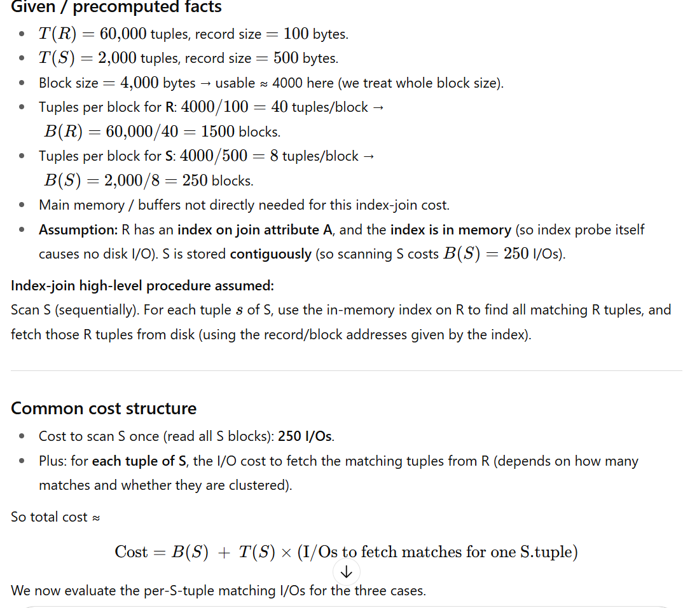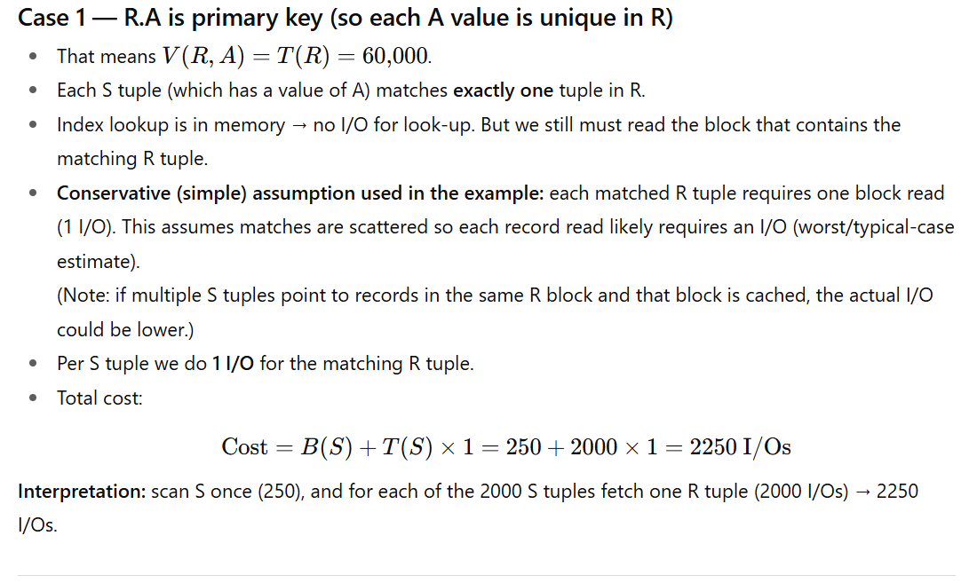
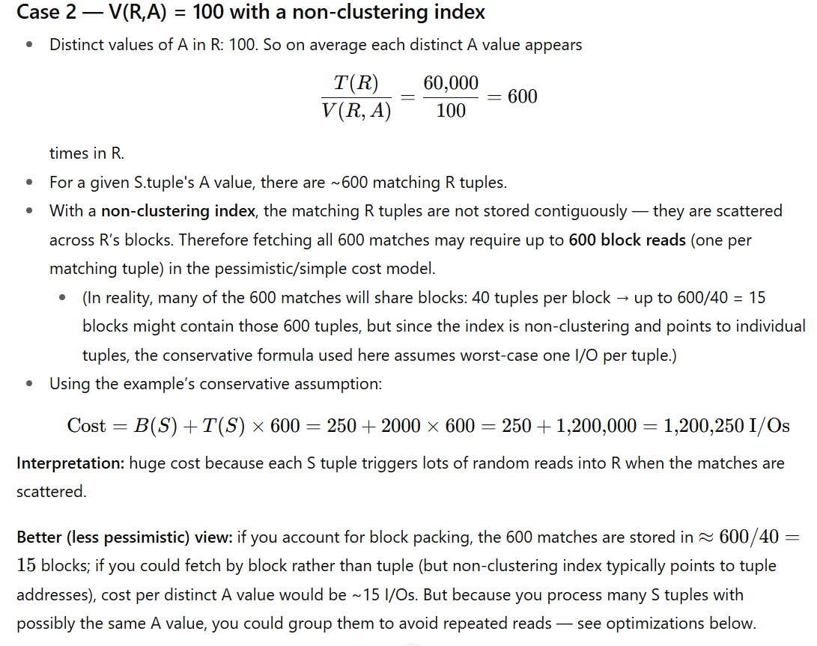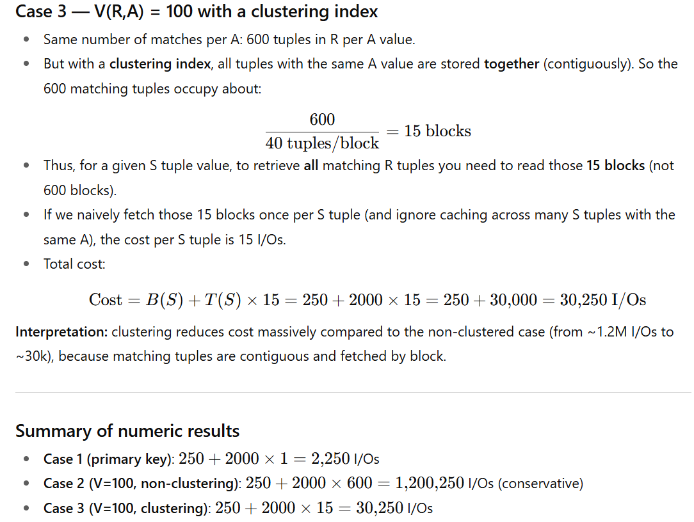

Important caveats & real-world optimizations
- Index probe cost: the slide assumes the index is entirely in memory, so index lookups cost no I/Os. If the index were on disk, index probes would add I/O overhead per lookup (often multiple I/Os), worsening costs.
- Caching / reuse across S tuples:
  - If many S tuples share the same A value, you should group S tuples by A value and fetch the corresponding R blocks once per distinct A value. That reduces repeated reads. Example: in Case 3 if many S tuples have the same A, you’d read the 15 blocks once, not for each S tuple.
  - Similarly, if the R blocks fetched remain in the buffer pool across iterations, repeated lookups may hit cache → lower actual I/O than the conservative model.
- Batching S tuples:
  - Instead of processing S tuple-by-tuple, read S in blocks and for each block perform index lookups, perhaps sorting S by A first so you process all identical A values together. Sorting or hashing S first (or using hash join) can be much cheaper than per-tuple index-joins when many matches exist.
- Better alternate algorithms:
  - If many matches per key exist (like 600), hash join or sort-merge join are usually more I/O efficient than index-join.
  - Index nested-loop join is most effective when the inner relation (R) is indexed and the number of matches per outer tuple is small (Case 1 is the ideal situation).

Final takeaway (practical rule-of-thumb)
- Index-join is attractive when: index in memory, the number of matching inner tuples per outer tuple is small (≈1), or matches are clustered (few blocks).
- If matches are many and scattered, index-join becomes very expensive; prefer block/partition/hash-based joins.
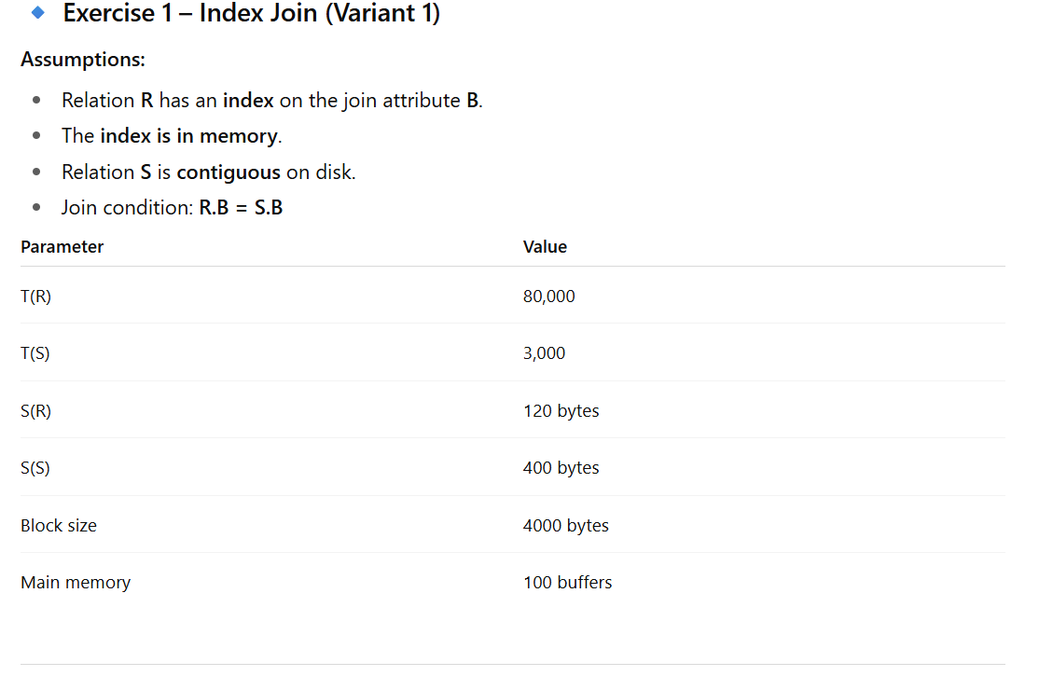

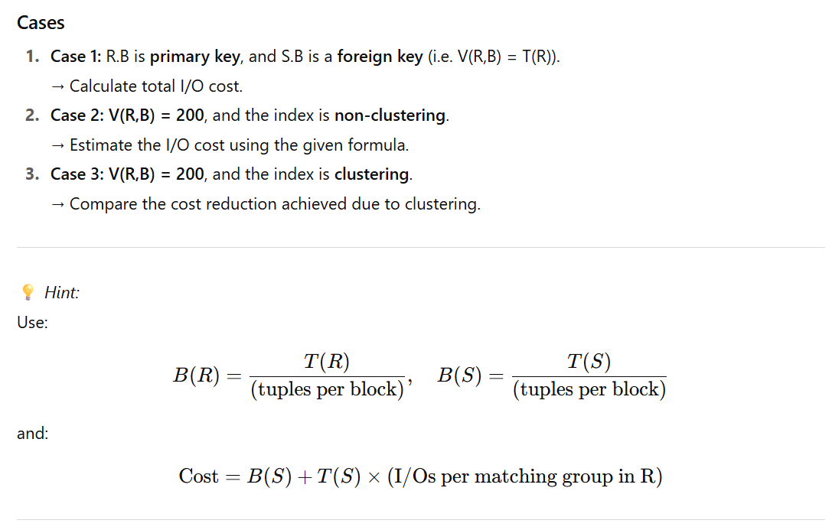
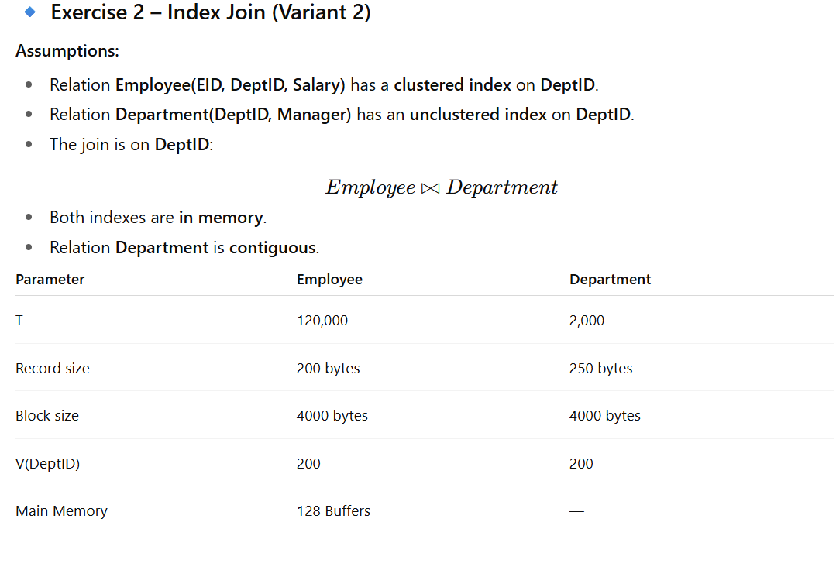
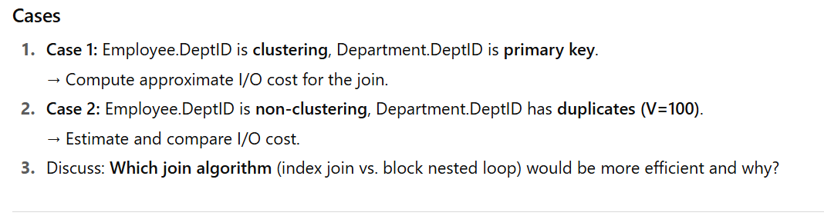
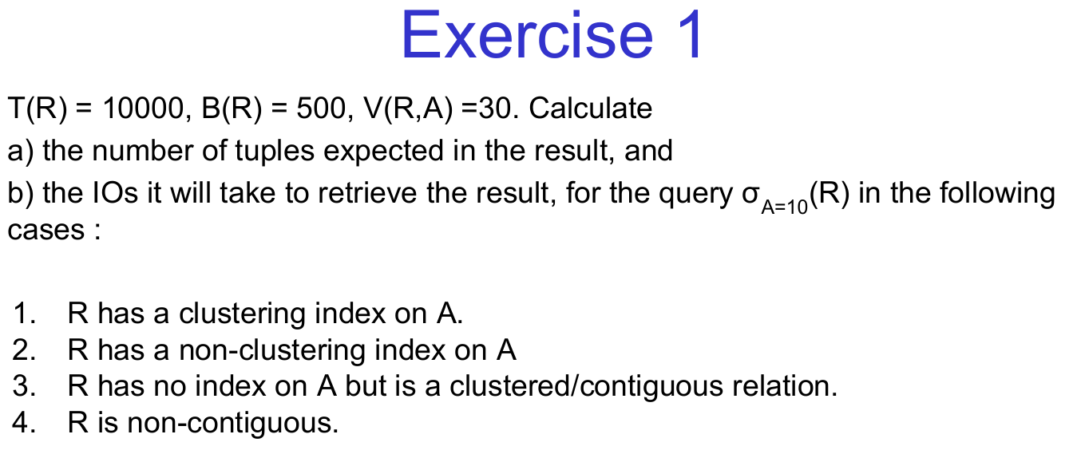

Exercise 1a
T(R) = 50,000, B(R) = 2,500, V(R, B) = 50. Calculate
a) the number of tuples expected in the result, and
b) the I/Os required to retrieve the result for the query σB=20(R) in the following cases:
- R has a primary B+ tree index on B.
- R has a secondary index (non-clustering) on B.
- R has no index on B but is stored sequentially.
- R is randomly scattered across disk pages.

Exercise 1b
T(R) = 20,000, B(R) = 1,000, V(R, C) = 25. Calculate
a) the number of tuples expected in the result, and
b) the I/Os required to retrieve the result for the query σC=5(R) in the following cases:
- R has a clustering index on C.
- R has a non-clustering index on C.
- R has no index on C but is sorted on another attribute.
- R is stored in an unordered fashion.

Exercise 1c
T(R) = 200,000, B(R) = 8,000, V(R, D) = 40. Calculate
a) the number of tuples expected in the result, and
b) the I/Os required to retrieve the result for the query σD=15(R) in the following cases:
- R has a clustered B-tree index on D.
- R has a hash-based index on D.
- R has no index on D but is clustered in storage.
- R is fragmented across multiple disks.

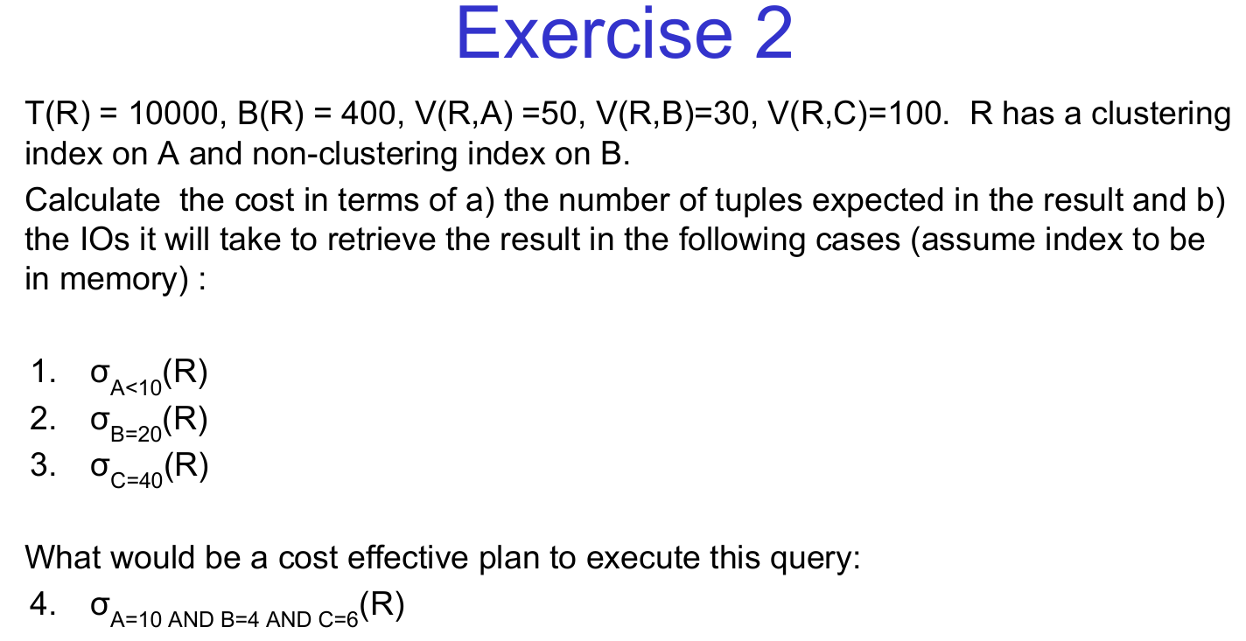

Exercise 2a
T(R) = 30,000, B(R) = 600, V(R, X) = 60, V(R, Y) = 40, V(R, Z) = 80.
R has a clustering index on X and a non-clustering index on Y.
Calculate the cost in terms of
a) the number of tuples expected in the result, and
b) the I/Os it will take to retrieve the result in the following cases (assume index is in memory):
- σX>15(R)
- σY=25(R)
- σZ=50(R)
What would be a cost-effective plan to execute this query:
4. σX=10 AND Y=8 AND Z=20(R)

Exercise 2b
T(R) = 50,000, B(R) = 1,000, V(R, P) = 100, V(R, Q) = 50, V(R, R) = 70.
R has a B+ tree index on P and a hash index on Q.
Calculate the cost in terms of
a) the number of tuples expected in the result, and
b) the I/Os it will take to retrieve the result in the following cases (assume index is in memory):
- σP<30(R)
- σQ=12(R)
- σR=40(R)
What would be a cost-effective plan to execute this query:
4. σP=5 AND Q=9 AND R=25(R)

Exercise 2c
T(R) = 20,000, B(R) = 500, V(R, M) = 90, V(R, N) = 60, V(R, O) = 120.
R has a clustering index on M and a secondary index on N.
Calculate the cost in terms of
a) the number of tuples expected in the result, and
b) the I/Os it will take to retrieve the result in the following cases (assume index is in memory):
- σM>50(R)
- σN=30(R)
- σO=80(R)
What would be a cost-effective plan to execute this query:
4. σM=20 AND N=10 AND O=50(R)

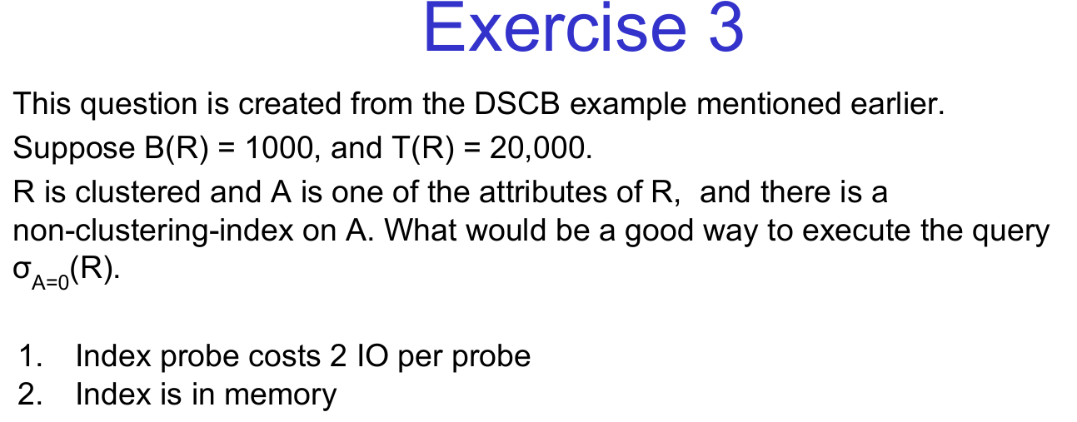

Exercise 3a
This question is based on a DSCB example.
Suppose B(R) = 800 and T(R) = 25,000.
R is clustered, and B is one of the attributes of R. There is a non-clustering index on B.
What would be a good way to execute the query σB=15(R)?
- Index probe costs 2 IO per probe.
- Index is in memory.

Exercise 3b
This question is based on a DSCB example.
Suppose B(R) = 500 and T(R) = 30,000.
R is not clustered, and C is one of the attributes of R. There is a secondary index on C.
What would be a good way to execute the query σC>20(R)?
- Index probe costs 3 IO per probe.
- Index is in memory.

Exercise 3c
This question is based on a DSCB example.
Suppose B(R) = 1,200 and T(R) = 15,000.
R is clustered, and D is one of the attributes of R. There is a non-clustering index on D.
What would be a good way to execute the query σD=5(R)?
- Index probe costs 1 IO per probe.
- Index is in memory.

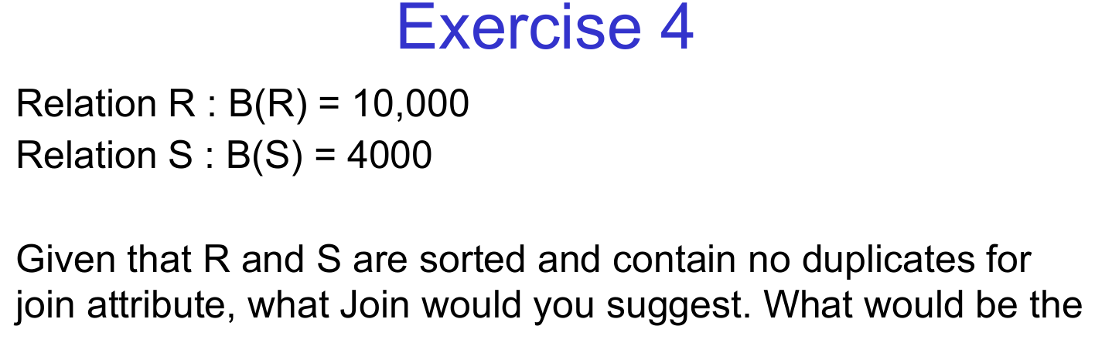

Question 4a: Join Selection for Sorted Relations
Relation R: B(R)=15,000 B(R)=15,000. Relation S: B(S)=5,000 B(S)=5,000
Given that R and S are sorted and contain no duplicates for the join attribute, what join algorithm would you suggest? What would be the total number of I/O operations required?

Question 4b: Join Selection for Large Relations
Relation R: B(R)=50,000 B(R)=50,000. Relation S: B(S)=20,000 B(S)=20,000
Given that R and S are sorted and contain no duplicates for the join attribute, what join algorithm would you suggest? What would be the total number of I/O operations required?

Question 4c: Join Selection for Small Relations
Relation R: B(R)=1,000B(R)=1,000
Relation S: B(S)=500B(S)=500
Given that R and S are sorted and contain no duplicates for the join attribute, what join algorithm would you suggest? What would be the total number of I/O operations required?

Explanation of Concepts in the Questions
- Sorted Relations: When both relations are sorted on the join attribute, a sort-merge join is often the most efficient choice.
- No Duplicates: The absence of duplicates simplifies the join process, as there is no need to handle multiple matches.
- I/O Operations: The total number of I/O operations depends on the size of the relations and the join algorithm used.

